**Roll No** **:- 131**

**Name:- VICHAVE RITIK BHIMRAO**

**Assingment N**o **:-** 1.2

**Assingment Title :-** Develop program to learn different types of structure in python

(Repetition).

* **for loop using range()****for** x **in** range(5):  
   print(x)
* **Output:-**

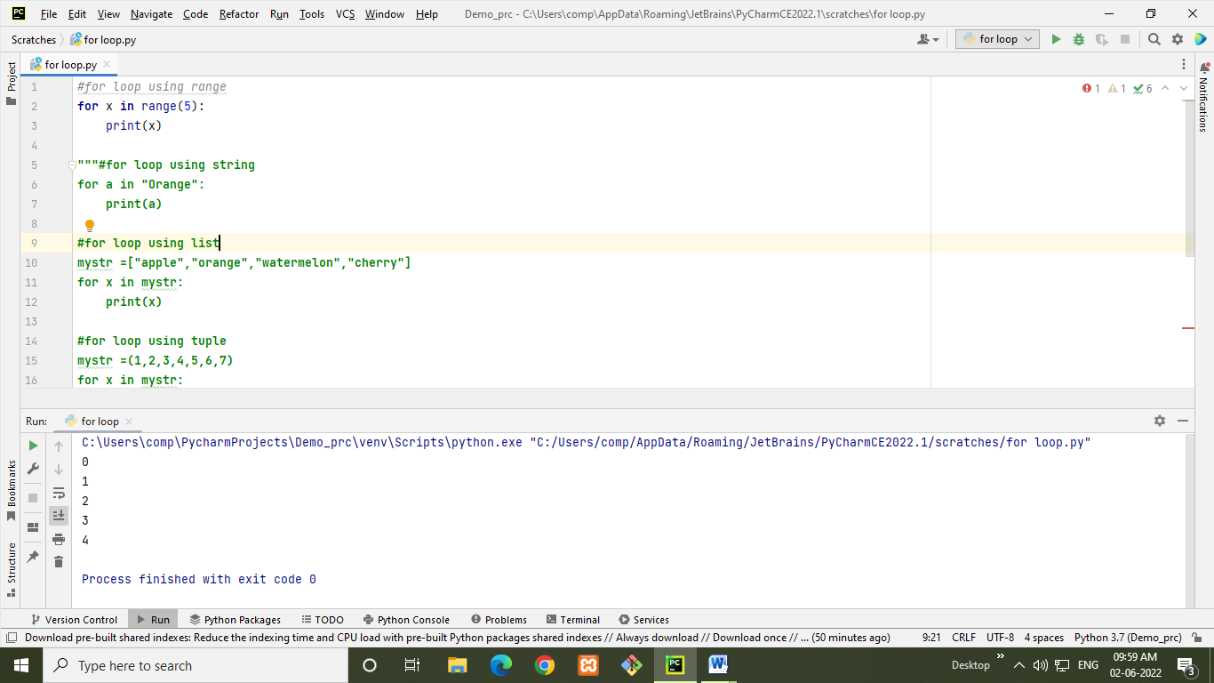

* **for loop using string**

**for** a **in "Orange"**:  
 print(a)

* **Output:-** 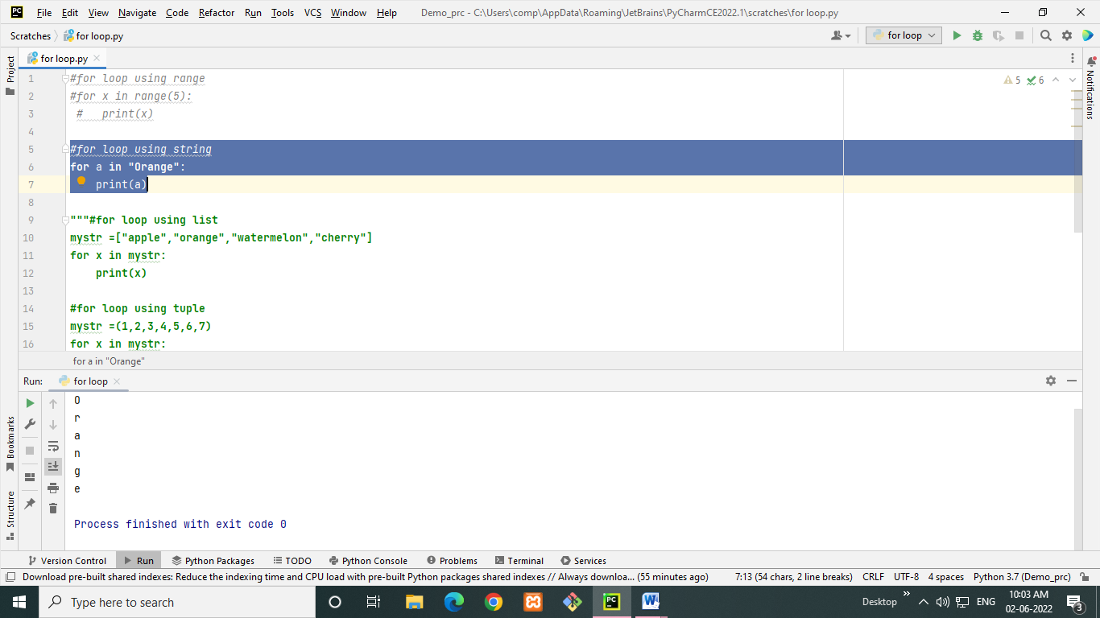
* **for loop using list**mystr =[**"apple"**,**"orange"**,**"watermelon"**,**"cherry"**]  
  **for** x **in** mystr:  
   print(x)
* **Output:-**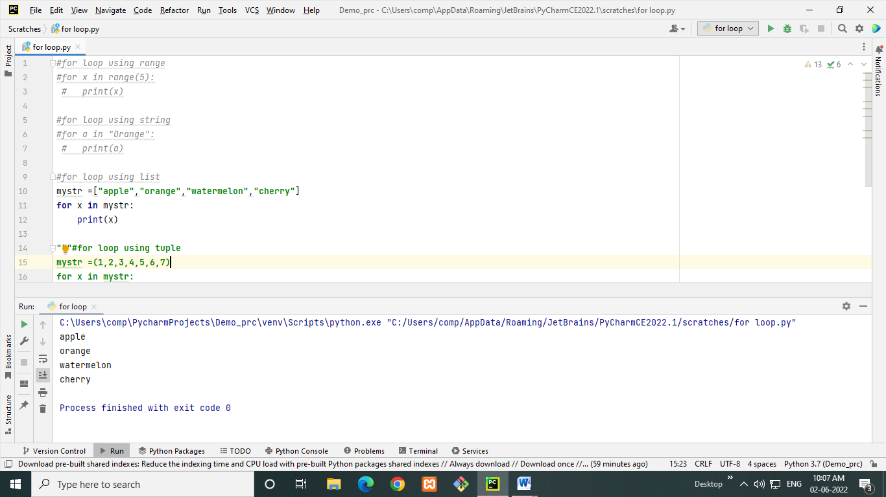
* **for loop using tuple**mystr =(1,2,3,4,5,6,7)  
  **for** x **in** mystr:  
   print(x)
* **Output:-**

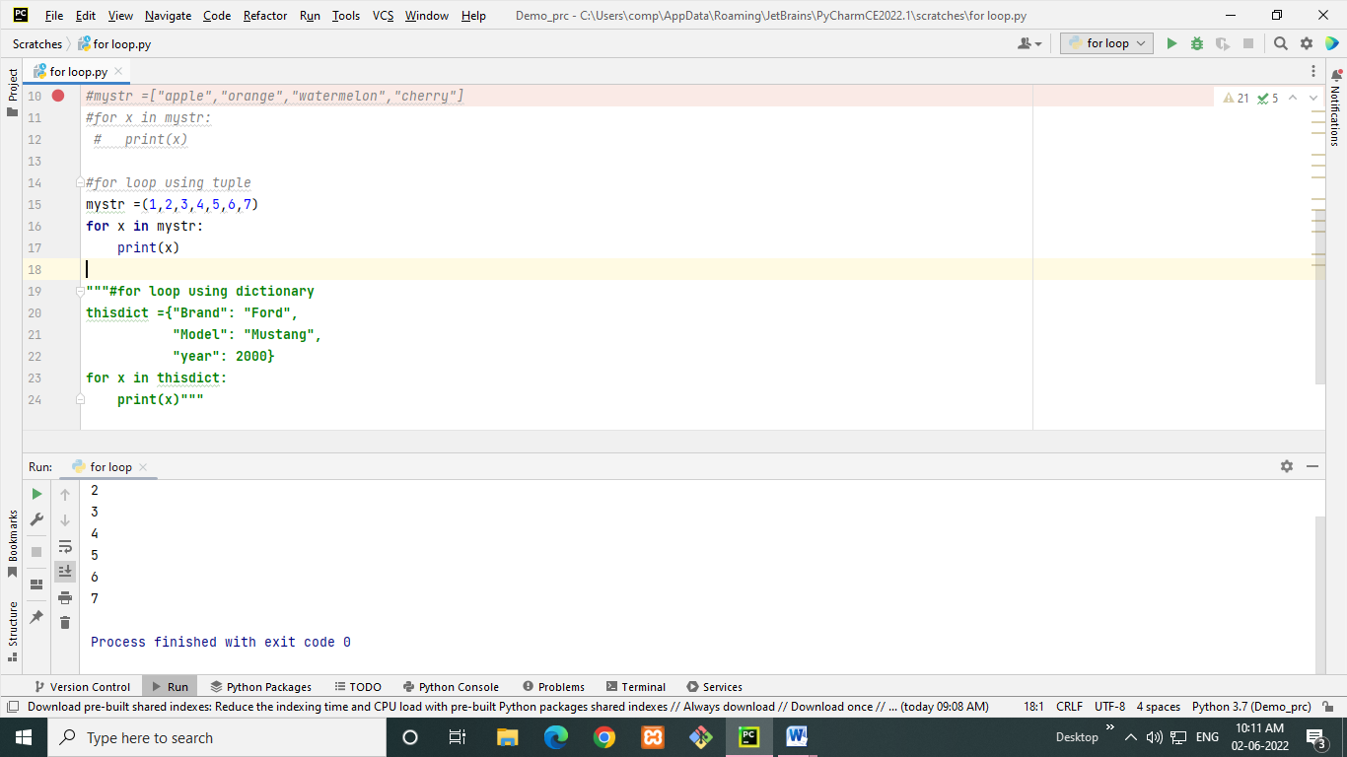

**for loop using dictionary** *# for loop using dictionary*stud = {'Name': 'RITIK', "Roll_No.": 131, 'Class': 'FYMCA'}  
empl = {'Name': 'RITIK', "ID": 10, 'Department': 'IT'}  
person = {'Name': 'RITIK', "City": 'Jalgaon', 'Gender': 'Male'}  
for x in stud.items():  
 print(x)  
  
for x in empl.items():  
 print(x)  
  
for x in person.items():  
 print(x)

* **Output:-**

